JavaScript Practicals
Index
S.No | Practical Name
1 | Write a program to enter the marks of students in 4 subjects and find out the sum and average of the marks obtained
2 | Write a program to enter a three digit number and find out the sum of all the digits
3 | Write a program to enter the number and find if the number is prime or not
4 | Write a program to print all the Armstrong numbers from 100 to 500
5 | Write a program to print first 20 prime numbers
6 | Write a JavaScript program to demonstrate all the events of the Keyboard and Mouse
7 | Write a ReactJS Component to find the largest among three numbers
8 | Write a NodeJS Code to create a server and send the Rno, Name and Marks in 4 subjects from the client form to the server and return the sum of the marks obtained

Practical 1 : Write a program to enter the marks of students in 4 subjects and find out the sum and average of the marks obtained
Source Code:
<html>
<head>
<title>Practical 1 - Sum & Average of Marks</title>
</head>
<body>
<h2>Sum & Average of Marks</h2>
<input id="s1" type="number" placeholder="Subject 1"><br><br>
<input id="s2" type="number" placeholder="Subject 2"><br><br>
<input id="s3" type="number" placeholder="Subject 3"><br><br>
<input id="s4" type="number" placeholder="Subject 4"><br><br>
<button onclick="calc()">Calculate</button>
<p id="res"></p>
<script>
function calc() {
var a = +document.getElementById('s1').value, b = +document.getElementById('s2').value, c = +document.getElementById('s3').value, d = +document.getElementById('s4').value;
var sum = a + b + c + d;
document.getElementById('res').innerHTML = "Sum: " + sum + "<br>Average: " + (sum / 4);
}
</script>
</body>
</html>
Output:
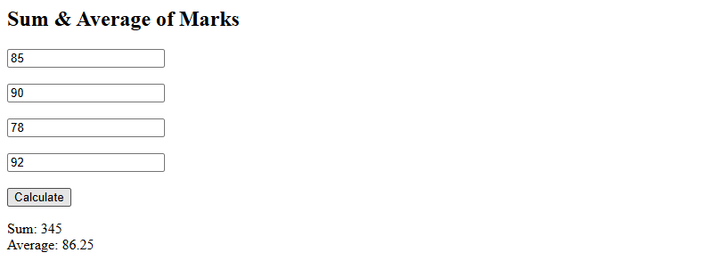

Practical 2 : Write a program to enter a three digit number and find out the sum of all the digits
Source Code:
<html>
<head><title>Practical 2 - Sum of Digits</title></head>
<body>
<h2>Sum of Digits of a Three Digit Number</h2>
<input id="num" type="number" placeholder="Enter 3 digit number">
<button onclick="calc()">Find Sum</button>
<p id="res"></p>
<script>
function calc(){
var n=document.getElementById('num').value;
var sum=0;
for(var i=0;i<n.length;i++) sum+=+n[i];
document.getElementById('res').innerText="Sum of digits: "+sum;
}
</script>
</body>
</html>
Output:
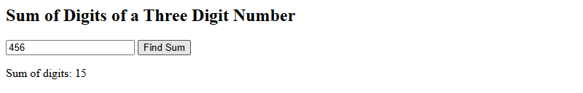

Practical 3 : Write a program to enter the number and find if the number is prime or not
Source Code:
<html>
<head><title>Practical 3 - Prime Check</title></head>
<body>
<h2>Prime Number Check</h2>
<input id="num" type="number" placeholder="Enter a number">
<button onclick="check()">Check</button>
<p id="res"></p>
<script>
function check(){
var n=+document.getElementById('num').value,prime=n>1;
for(var i=2;i<=Math.sqrt(n);i++){if(n%i==0){prime=false;break;}}
document.getElementById('res').innerText=n+(prime?" is Prime":" is Not Prime");
}
</script>
</body>
</html>
Output:
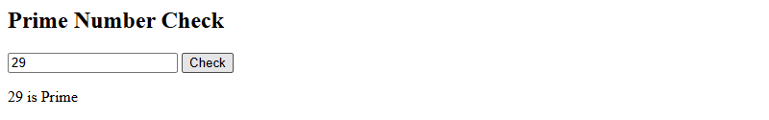

Practical 4 : Write a program to print all the Armstrong numbers from 100 to 500
Source Code:
<html>
<head><title>Practical 4 - Armstrong Numbers</title></head>
<body>
<h2>Armstrong Numbers from 100 to 500</h2>
<button onclick="find()">Find</button>
<p id="res"></p>
<script>
function find(){
var r=[];
for(var i=100;i<=500;i++){
var s=0,t=i.toString();
for(var j=0;j<t.length;j++) s+=Math.pow(+t[j],t.length);
if(s==i) r.push(i);
}
document.getElementById('res').innerText="Armstrong Numbers: "+r.join(", ");
}
</script>
</body>
</html>
Output:
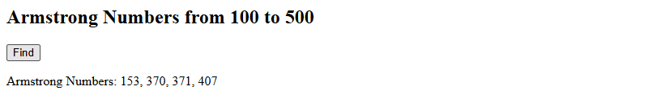

Practical 5 : Write a program to print first 20 prime numbers
Source Code:
<html>
<head><title>Practical 5 - First 20 Primes</title></head>
<body>
<h2>First 20 Prime Numbers</h2>
<button onclick="find()">Find</button>
<p id="res"></p>
<script>
function find(){
var primes=[],n=2;
while(primes.length<20){
var ok=true;
for(var i=2;i<=Math.sqrt(n);i++){if(n%i==0){ok=false;break;}}
if(ok) primes.push(n);
n++;
}
document.getElementById('res').innerText=primes.join(", ");
}
</script>
</body>
</html>
Output:
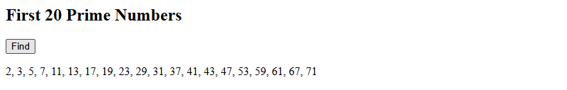

Practical 6 : Write a JavaScript program to demonstrate all the events of the Keyboard and Mouse
Source Code:
<html>
<head><title>Practical 6 - Keyboard & Mouse Events</title>
<style>
#box{width:200px;height:200px;background:#ccc;display:flex;align-items:center;justify-content:center;margin:10px 0;cursor:pointer}
</style>
</head>
<body>
<h2>Keyboard & Mouse Events</h2>
<input id="inp" placeholder="Type here for keyboard events"><br><br>
<div id="box">Hover/Click Me</div>
<p id="log"></p>
<script>
var log=document.getElementById('log');
function show(e){log.innerHTML=e+"<br>"+log.innerHTML;}
var inp=document.getElementById('inp');
inp.onkeydown=function(e){show("keydown: "+e.key);};
inp.onkeyup=function(e){show("keyup: "+e.key);};
inp.onkeypress=function(e){show("keypress: "+e.key);};
var box=document.getElementById('box');
box.onclick=function(){show("click");};
box.ondblclick=function(){show("dblclick");};
box.onmousedown=function(){show("mousedown");};
box.onmouseup=function(){show("mouseup");};
box.onmouseover=function(){show("mouseover");};
box.onmouseout=function(){show("mouseout");};
box.onmousemove=function(e){show("mousemove: "+e.clientX+","+e.clientY);};
box.oncontextmenu=function(e){e.preventDefault();show("contextmenu (right-click)");};
</script>
</body>
</html>
Output:
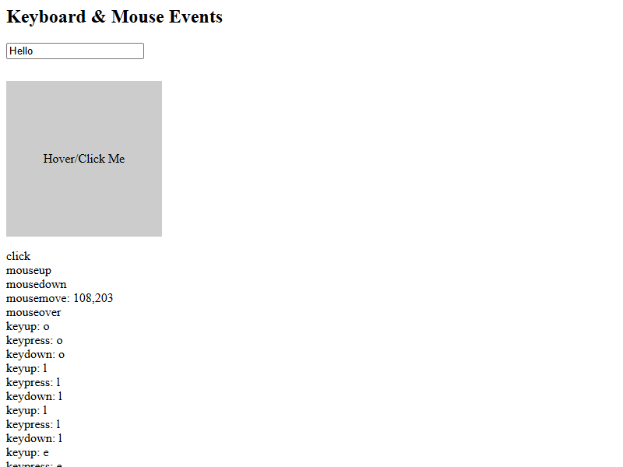

Practical 7 : Write a ReactJS Component to find the largest among three numbers
Source Code:
<html>
<head>
<title>Practical 7 - Largest Among Three (ReactJS)</title>
<script src="https://unpkg.com/react@18/umd/react.development.js"></script>
<script src="https://unpkg.com/react-dom@18/umd/react-dom.development.js"></script>
<script src="https://unpkg.com/@babel/standalone/babel.min.js"></script>
</head>
<body>
<div id="root"></div>
<script type="text/babel">
function App(){
const [a,setA]=React.useState('');
const [b,setB]=React.useState('');
const [c,setC]=React.useState('');
const [res,setRes]=React.useState('');
function find(){
setRes("Largest: "+Math.max(+a,+b,+c));
}
return(
<div>
<h2>Find Largest Among Three Numbers (ReactJS)</h2>
<input type="number" placeholder="Number 1" value={a} onChange={e=>setA(e.target.value)}/><br/><br/>
<input type="number" placeholder="Number 2" value={b} onChange={e=>setB(e.target.value)}/><br/><br/>
<input type="number" placeholder="Number 3" value={c} onChange={e=>setC(e.target.value)}/><br/><br/>
<button onClick={find}>Find Largest</button>
<p>{res}</p>
</div>
);
}
ReactDOM.createRoot(document.getElementById('root')).render(<App/>);
</script>
</body>
</html>
Output:
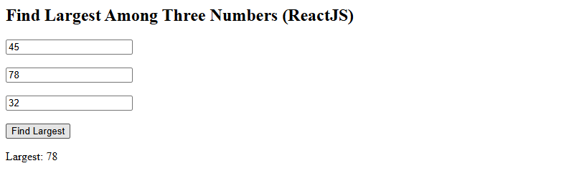

Practical 8 : Write a NodeJS Code to create a server and send the Rno, Name and Marks in 4 subjects from the client form to the server and return the sum of the marks obtained
Source Code (practical8_client.html):
<html>
<head>
<title>Practical 8 - Student Marks Form</title>
</head>
<body>
<h2>Student Marks Form</h2>
<form method="POST" action="/">
<input name="rno" placeholder="Roll No"><br><br>
<input name="name" placeholder="Name"><br><br>
<input name="m1" type="number" placeholder="Subject 1"><br><br>
<input name="m2" type="number" placeholder="Subject 2"><br><br>
<input name="m3" type="number" placeholder="Subject 3"><br><br>
<input name="m4" type="number" placeholder="Subject 4"><br><br>
<button type="submit">Submit</button>
</form>
</body>
</html>
Source Code (practical8_server.js):
const http = require('http');
const qs = require('querystring');
http.createServer((req, res) => {
if (req.method === 'GET') {
res.end(“Server is running”);
} else {
let body = '';
req.on('data', d => body += d);
req.on('end', () => {
const p = qs.parse(body);
const sum = +p.m1 + +p.m2 + +p.m3 + +p.m4;
res.writeHead(200, { 'Content-Type': 'text/html' });
res.end('<html><body><h2>Result</h2><p>Roll No: ' + p.rno + '</p><p>Name: ' + p.name + '</p><p>Marks: ' + p.m1 + ', ' + p.m2 + ', ' + p.m3 + ', ' + p.m4 + '</p><p><b>Sum: ' + sum + '</b></p><a href="/">Back</a></body></html>');
});
}
}).listen(3000, () => console.log('http://localhost:3000'));

Output (Before Submit):
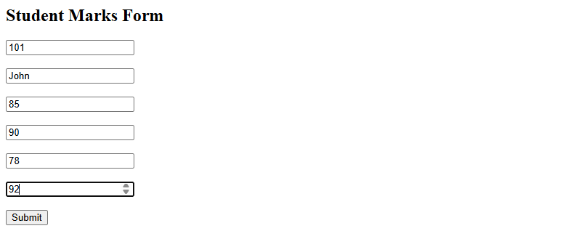
Output (After Submit):
